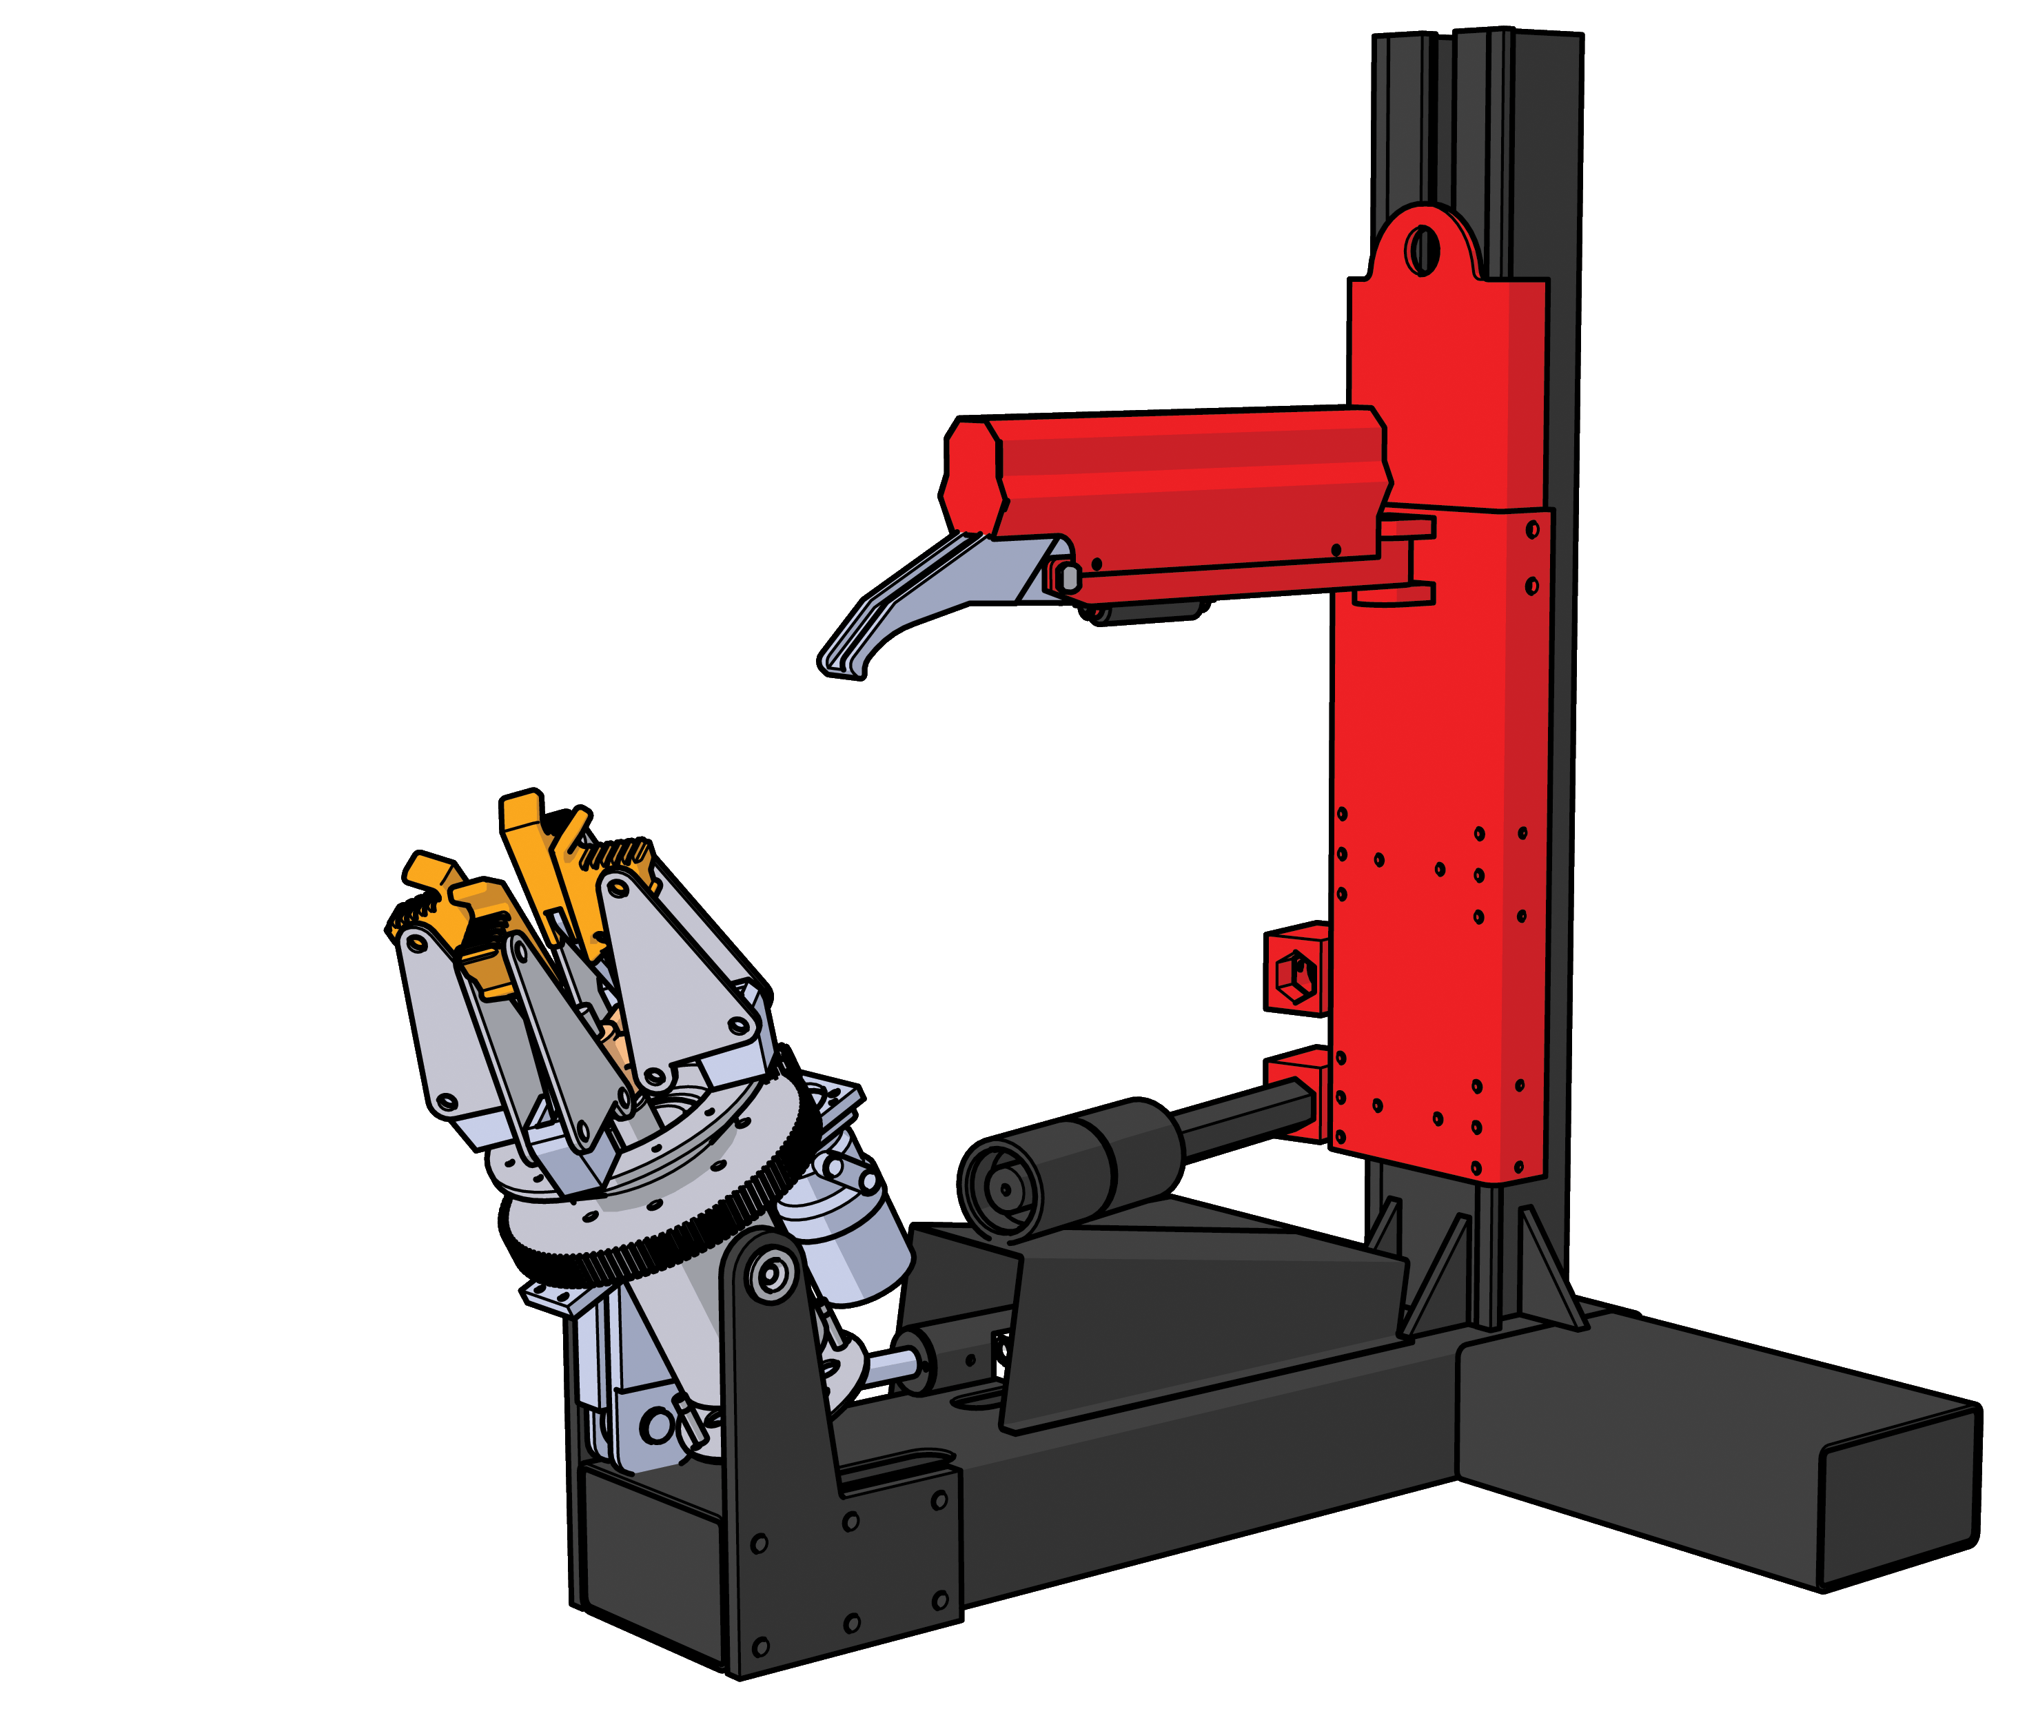
INSTRUCTIONS FOR USE
Vertical truck tire changer

INDEX

1 - FOREWORD 2
2 - GENERAL SAFETY AND ACCIDENT-PREVENTION RULES 2
3 - WORKPLACE ENVIRONMENT 4
4 - RESIDUAL HAZARDS 5
4.1 - CRUSHING HAZARD. 5
4.2 - HAZARD OF THE TIRE TO FALL FROM THE CLAMP 5
4.3 - ELECTRIC HAZARD 6
4.4 - ENTANGLING HAZARD 6
4.5 - GENERIC HAZARDS 6
4.6 - EMERGENCY STOP 7
5 - GENERAL DESCRIPTION 8
5.1 - TECHNICAL DATA 8
5.2 - OPERATION ENVIRONMENT CONDITION 10
6 - TRANSPORT AND STORAGE 10
6.1 - STORAGE 11
6.2 - UNPACKING 11
7 - INSTALLATION 12
7.1 - INSTALLATION PLACE 12
7.2 - NEEDED TOOLS 13
7.3 - WORKPLACE REQUIREMENT 14
7.4 - ELECTRIC CONECTION 14
8 - PREPARATION 16
8.1 - SAFETY PICTOGRAMS 16
8.2 - IDENTIFICATION AND CE MARKING LABEL 19
8.3 - MACHINE LAYOUT 20
8.4 – CONTROLS AND WORKING POSITION 20
8.5 - PREPARATION 21
8.6 - FINAL ADJUSTMENTS, HYDRAULICS 22
8.6.1 - ADDITIONAL INFORMATION ON THE HYDRAULIC CIRCUIT: 23
8.7 - OWNER OPERATOR CHECK LIST 23
9 - OPERATION 24
9.1 – IDENTIFYING DIRECTION OF THE RIM 26
9.2 – INSTALLING THE WHEEL ON THE MACHINE 26
9.3 – OPERATION 27
9.4 – TIRE REMOVAL 28
9.5 – TIRE INSTALLATION 29
9.6 – OPERATING ON SPECIAL TIRES 30
9.7 – INFLATING THE TIRE 30
10 - ORDINARY MAINTENANCE 32
10.1 - PERIODICAL CHECKS 33
10.2 - SPECIFIC CHECKS 33
10.3 – OIL SAFETY DATASHEET 35
11 - DISMANTLING OF THE MACHINE AND SCRAPPING 36
12 - TECHNICAL ASSISTANCE 37
13 - TROUBLE SHOOTING 37
14 - SPARE PARTS 38
14.1 - SPARE PARTS BREAKDOWN 38
15 - ACCESSORIES 40
ANNEX I - INSTALLATION CHECK LIST 41
ANNEX II - PERIODICAL CHECKS 42
EC DECLARATION OF CONFORMITY 43


ATTENTION
WARNING | Only trained and authorized persons shall be allowed to maintenance/operate this equipment.  Copy of this manual shall be given to any person authorized to operate the machine; the owner of the machine shall make sure that any person authorized to use the machine has fully read and understood the present manual, therefore knowing how to use the machine in safe conditions. |  | 
 | A safe use is guaranteed only meticulously following the instructions listed in this manual, especially for trouble shooting. The machine shall not be put in service until when the user has been completely read and understood the contents of this manual.
 |  | The pictures present in this booklet are taken on the original design of the machine. The picture may be slightly different from the actual equipment.

1 - FOREWORD

This manual contains the instructions for handling, installation, use and maintenance of Vertical truck tire changer.
This manual is an essential part of the machine and it shall be opportunely taken care of. In case of its damaging or loss, a duplicate can be asked to the manufacturer who will provide a copy. The content of the present is in compliance with Directive 2006/42/CE.
WARNING | Compliance with the instructions herein provided will allow for the safe operating of the system during the handling, installation, operating and maintenance stages and assure at the same time the proper functioning and cost-effectiveness of the machine.

Different equipment models of machines are likely to have different instructions for use. The operator shall pay outmost attention to the validity of the instructions he is referring to.

2 - GENERAL SAFETY AND ACCIDENT-PREVENTION RULES

Pay careful attention to the danger signs when they appear in this manual. There are three levels of danger signs:

DANGER | This sign warns that, if the operations described are not carried out correctly, the user is exposed to serious risks which may result in injuries, death or long-term damage to his health.
WARNING | This sign warns that, if the operations described are not carried out correctly, the user is exposed to risks which may result in injuries, death or long-term damage to his health.
CAUTION | This sign warns that, if the operations described are not carried out correctly, the machine risks being damaged.

This manual is addressed to the user of the machine and to the person who has the responsibility of its correct and safe use.
Read carefully the warnings contained in this manual, which is also supplying the indications for a correct and hazard free use of the machine. Familiarize with the controls and the operations required for the use of the machine in emergency conditions. Always keep this manual by the machine, in order to consult it in the event of any future possible need. The manual shall follow the machine in case it is sale.

DANGER | In order to prevent risks to third parties and/or damages to things, before any operation takes place, the user shall make sure that no things or unauthorised persons stand close to the machine before starting any working cycle.
DANGER | Before using the tire changer, make sure that required protective apparels are used (protective gloves, goggles…). |  | 
DANGER | Immediately point out any problem or breakdown, including eventual defects detected on the control unit and/or on the hydraulic and electric connections, to the owner of the machine or to the person in charge of its safe use.
 |  | The user in charge of the machine shall be a person fit for the job and shall have a perfect knowledge of how the system's equipment is to be used. He shall follow the instructions provided to guarantee their safety and the safety of others

This machine has been designed, constructed and CE approved in compliance with the 2006/42/EC Machine Directive (MD).
The standard applies to machine manufactures, as well as to owners and employers. The owner/employer’s responsibilities are summarized below.
The Owner/Employer shall insure that machine operators are qualified and that they are trained in the safe use and operation of the machine using the manufacturer’s operating instructions.
The Owner/Employer shall establish procedures to periodically inspect the machine in accordance with the machine manufacturer’s instructions. The employer shall insure that the machine inspectors are qualified and that they are adequately trained in the inspection of the machine.
The Owner/Employer shall establish procedures to periodically maintain the machine in accordance with the machine manufacturer’s instructions. The employer shall insure that the machine inspectors are qualified and that they are adequately trained in the inspection of the machine.
The Owner/Employer shall maintain the periodic inspection and maintenance records recommended by the manufacturer.
The Owner/Employer shall display the machine manufacturer’s operating instructions in a conspicuous location in the machine area convenient to the operator.

3 - WORKPLACE ENVIRONMENT

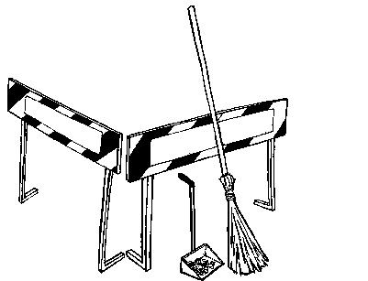 | Workplace environment must be clean and in orderly conditions. In particular, hazardous areas must be duly delimited.  The field of motion of the load and of the load carrying devices shall be free of obstructions.
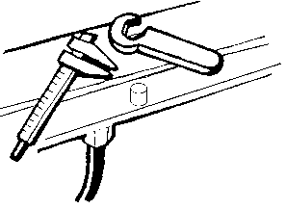 | The work tools and materials shall not be left on the machines (or in places where these may interfere with its mechanical movements) or kept in places where they may fall and hence cause accidents.
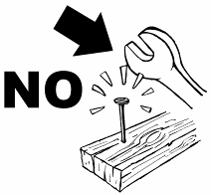 | Each tool must be used exclusively for the use it was designed for and in the most suitable way.
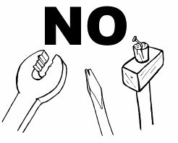 | Never use tools that are deteriorated.
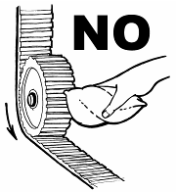 | 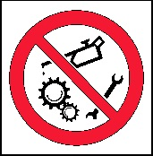 | Do not clean nor touch any mechanical part while in motion.
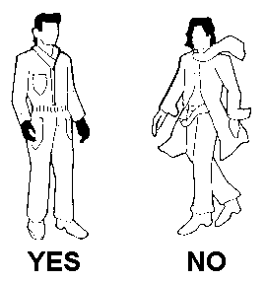 | The use of loose-fitting working cloths (e.g. scarves, button-down shirts, etc.) can be hazardous. Always wear close-fitting garments.
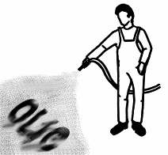 |  | Any oil or grease on the floor shall be removed immediately to prevent any risk of slipping or falling.

4 - RESIDUAL HAZARDS

DANGER | It is mandatory to the owner of the machine and/or the person in charge of it, to supply to the final user all the necessary information and aids to the safeguard of its physical health.
All the various stages - Designing, Construction, Selection of the sub-contractors and Final Inspection - involving the manufacturing processes of Vertical truck tire changer were carried out with the outmost care and attention to assure compliance of the product with the strictest safety standards through its high mechanical and engineering quality.
It is, however, necessary to specify that, notwithstanding:
- the attentions taken in the designing phase;
- the care and control given to the manufacturing process;
the machine object of this manual has, however, some risks that, for the specific type of job to execute, cannot be completely eliminated with the aid of security systems. Such risks are later on listed. It is absolutely necessary therefore that the operator is informed of such risks and that uses the machine with the maximum precaution. Familiarize with the controls and the operations described in this manual to use the machine in safe conditions.
Always keep this manual together with the machine so as to make immediately possible any future consultation. The manual shall follow the machine in case of its sale. A safe use is only guaranteed for the functions listed in this manual.
DANGER | Never use the machine before having verified that all the emergency devices are installed correctly and operative.

4.1 - CRUSHING HAZARD.

This hazard is present while loading/unloading the wheel on the clamp and while rotating the wheel support.
DANGER |  | In order to prevent risks to the operator during the loading/unloading of the wheel, is required the use of personal protective equipment such as protective gloves and protective injuries shoes.
DANGER | 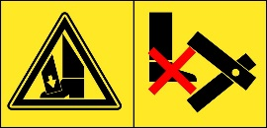  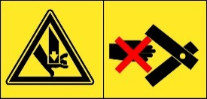 | In order to prevent risks to third parties and/or damages to things, before any operation takes place, the user shall make sure that there are no things or persons in the field of motion of machine before and while operating it.
WARNING | The flow limiting devices are setup and tested at the factory to operate in standard working conditions (20°C and 46 Cst oil). The setup of the device can be heavily affected by the working conditions (including temperature, oil viscosity and humidity). If the machine is to be used in different working conditions from the standard design criteria, then the flow limiting device setup shall be verified and approved by authorised personnel. A wrongly setup flow limiting device could generate a serious hazard.

4.2 - HAZARD OF THE TIRE TO FALL FROM THE CLAMP

This hazard is present while working on the tire, if the rim was not properly clamped. The user shall make sure that the tire is correctly positioned on the clamp and that all the actions are taken at a reduced speed.

4.3 - ELECTRIC HAZARD

This hazard is present if the electric connections are not compliant to the applicable safety local norms. For machine installation and operation for single phase units, it is necessary to have a dedicated circuit with a double pole 25 amp circuit breaker or time delay fuse.
DANGER |  | Before connecting the machine to the electric line, verify that the line itself is completely compliant to the enforced norm.  Also make sure that the electric line can supply the needed power and that:  - there is a properly working grounding circuit  - there is a properly working protection
DANGER |  | Before plugging the machine to the main power supply or before any maintenance work, make sure that the main switch of the power supply is set to the OFF (0) position.

4.4 - ENTANGLING HAZARD

This hazard is present while operating the wheel clamp.
DANGER |  | In order to prevent risks to the operator during the loading/unloading of the wheel, is required the use of personal protective equipment such as protective gloves and protective injuries shoes.

4.5 - GENERIC HAZARDS

Any other use or operation not in compliance with this manual could cause damages to the user and or to the machine.
An un-forecasted and unexpected use alters the technical characteristics for which the machine has been designed and manufactured and could then compromise its correct and safe use.
 | DANGER | The machine was designed for indoor operation only. Do not install and/or use this machine outdoor.
 | DANGER | It is not allowed to perform any type of aid and/or maintenance operation to the machine while being operated.
 | DANGER | Do not wash the tire/rim while mounted on the machine.
 | DANGER | Before operating the machine, visually check all the components of the machine and in particular the safety devices for possible defects. Do not operate the machine even if any defect is detected.
 | DANGER | 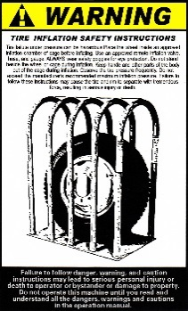 |  |  | The failure of the tire under pressure can be very hazardous. Tire explosion may cause serious injury to the operator and even cause death.  Only inflate the tire after having placed the wheel inside an approved inflation chamber.  Do not stand beside the wheel and the cage during the inflation.  Do not exceed the manufacturer recommended maximum inflating pressure.
 | DANGER | Do not exceed the maximum pressure specified by the tire manufacturer.  The operator must stay as far as possible from the tires, when inflating it.  Before inflating the tire:  - Check carefully whether the rim is the same size as the tire;  - Check the wear status of the tire;  - Install a new gas nozzle on the rim;  - Make sure the tire is well lubricated.  While inflating the tire:  - Check tire pressure frequently;  - Never inflate at a pressure higher of 3.5bar and , in any case, do not exceed the manufacturer's recommended pressure;  - Keep body and hands as far as possible away from the tires;  - Make sure that the rim is firmly held on the chuck;  - Make sure that the removable head and the tire roller have been removed and are located as far as possible from the tire being inflated;
 | DANGER |  |  | Even if the machine is not particularly noisy, during inflating operation the noise may reach up to 85dB (A). The operator must use the associated protective equipment.
 | DANGER | If the rim or tire status is not good or if the replacement operation is performed correctly, a puncture on the replaced tire is possible.
ATTENTION |  |  | Do not smoke while performing any maintenance, installation and assembly operation on the machine. |  |  | 

4.6 - EMERGENCY STOP

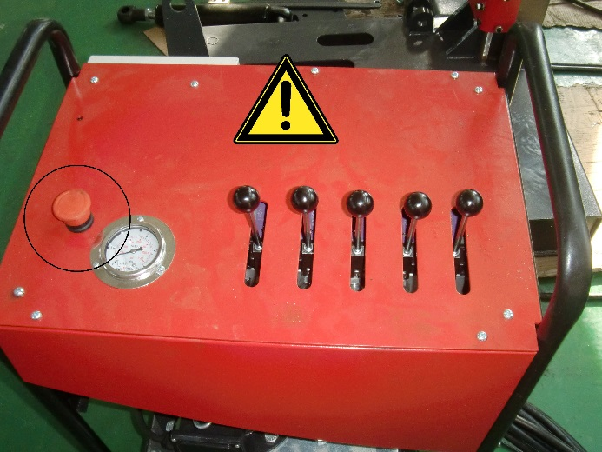  Figure 1 | The Emergency Stop command can be given by operating the emergency mushroom type switch (round, yellow/red), ref. §5.3.3 and §10.7.4 of EN 60204-1. By pushing it, the hydraulic pump will be deactivated and the machine will immediately stop.  It is not possible to engage the emergency device without triggering a stop command. The release of the emergency device is only possible with a voluntary action that does not restart the machine but only authorises its return to service.  The stop command has priority over the start controls.

5 - GENERAL DESCRIPTION

Vertical truck tire changer has been specifically designed to demount and mount truck, bus , tractors and earth moving vehicles tires, with rims from 19”to 26” and a maximum 1400mm (55”) wheel diameter having a weight of up to 380kg.
DANGER | 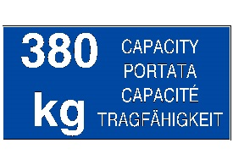 | Do not overload for any reason the machine. The maximum allowable wheel weight is agreed to be the maximum total weight that can be loaded on machine.

A
Any other use is improper and therefore not authorized. Before beginning any kind of work on or with this machine, carefully read and understand the contents of these operation instructions.

5.1 - TECHNICAL DATA

WARNING | Dimensions and specifications of Vertical truck tire changer could be subject to change without notice.

Vertical truck tire changer has been specifically designed to demount and mount exclusively truck, bus and heavy duty vehicles tires.

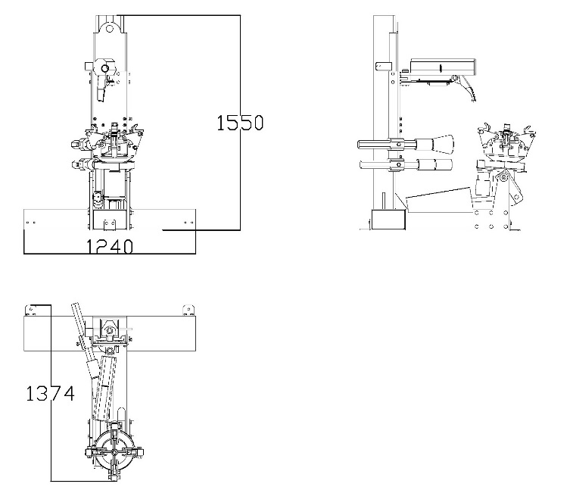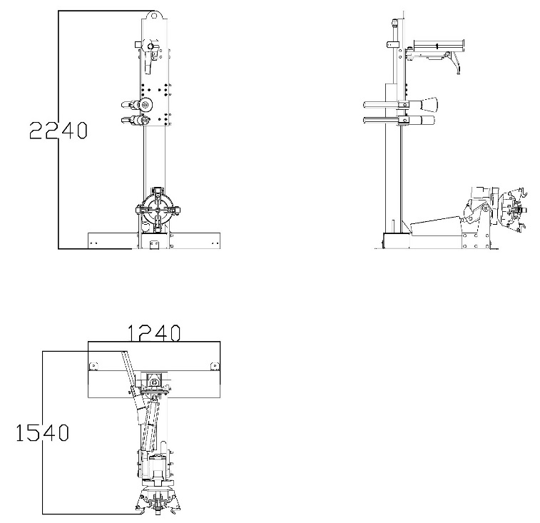
Figure 2

Power supply: | 220-240-380-400V/1OR3Ph/ 50 Hz |  | Machine total weight: | 485 kg
Hydraulic pump motor: | 3.0 kW  220-240-380-400V/1OR3Ph/ 50 Hz |  | Package total weight approx: | 560 kg
Gearbox motor: | 2.4/3.0 kW  220-240-380-400V/1OR3Ph/ 50 Hz |  | Overall dimensions: | 1374x1240x1540 mm
Full load current: | 30 A |  | Package dimensions: | 1300X1220X1720 mm
Short-current capacity: | 6 kA |  | Rated oil working pressure: | 14 MPa
Rim diameter: | 19"÷26" |  | Max allowed oil pressure: | 15 MPa
Claw range | 5”÷15” |  | Oil tank capacity: | 15 dm³
Max wheel weight: | 380 kg |  | Noise | <70db(A)
Max tire diameter: | 1400 mm (55”) |  | Spindle speed | 6.8rpm
Max wheel width: | 460 mm (18”) |  | Pressure roll pressure | 3500 kg
 |  |  | Hook pressure | 2000 kg

DANGER | Do not tamper with the set-up of the maximum pressure valve. Its modification immediately voids the warranty on the machine and could have consequently serious hazards for the user.

5.2 - OPERATION ENVIRONMENT CONDITION

Temperature working range: | 4÷40 °C
Humidity: | 50%@40°C, 90%@20°C
Altitude: | ≤1000 m

CAUTION | Dust content in the air is required to be ≤10mg/m³.  In the air, corrosive and/or toxic gas must not be present.
DANGER | Do not operate the machine in a flammable and/or explosive environment.

6 - TRANSPORT AND STORAGE

DANGER | The equipment must only be shipped/stored in original packaging.  Equipment must be stored/transported at a temperature comprised between -20°C and +50°.

The product is provided with a convenient lifting hinge, which was designed for the purpose of displacing the machine in safe conditions.
DANGER | 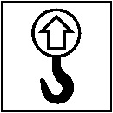 | Only displace the machine using appropriate lifting devices and only use the specifically provided for lifting hinges.
CAUTION | Pay attention to possible unexpected movements of the post and/or of the arm while displacing the machinery.

In order to store the machine, follow these instructions:
- Demount the roller arm;
- Raise the turntable holding arm;
- Close the jaws of the chuck;
- Lower the column;
- Disconnect the machine form all power sources.
- Disconnect the hydraulic lines;
- Insert into the lifting hinge a hoisting belt (at least 60 mm wide and of a length sufficient to bring the hook of the belt above the tire changer);
- With the special belt ring bring the 2 ends of the belt together and lift with a sufficiently strong lifting device.
The machine can now be packaged in a wooden crate with a pallet.
DANGER | Always load, unload and handle the machine package paying the utmost attention to possible hazards, in particular make sure that there are no persons or things in the range of the lifting device.
DANGER | Protect the packed machine with a plastic cover | 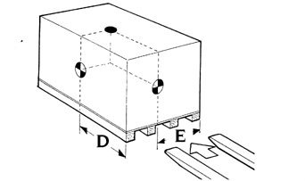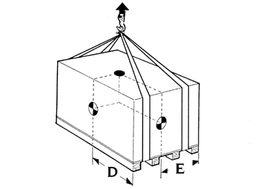
Before displacing the machine check its barycentre and weight to make sure they are compatible with the lifting equipment you are about to use (Figure 3).
 |  | Figure 3
To displace the packed machine insert the forks of a forklift in the channels in the base of the pallet.
If you use a crane or hoist to displace the machine, use approved web slings or cables. The shipping weight for the machine is ~560kg.

6.1 - STORAGE

The machine must be stored at a temperature between -25°C and +55℃. If the machine as to be stored for a long time (3~4 month or more) you have to:
- Grease all the parts that could be damaged if they dry out:
  - The chuck;
  - The slot of the tool holding arm;
  - The slides of the carriage;
  - The tool.
- Empty oil/ hydraulic fluid reservoirs and wrap the machine in a sheet of protective plastic to prevent dust from reaching the internal working parts.
If the machine has to working again after a long storing period, it is necessary to:  - Put the oil into the reservoirs again;  - With a turn screw press the pin on the middle of the electro-valves in order to manually unlock the electro-valves which could be locked after a long period of inactivity; | 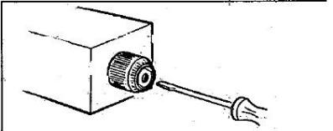
 | Figure 4
- Restore the electric connection.
If the machine, before being unpacked, needs a temporary storage, keep it in a covered dry place.

6.2 - UNPACKING

Once positioned the load close to the point in which the machine shall be installed, remove the eventual packing.
DANGER |  | Execute any maintenance, installation and assembly operation on the machine wearing proper protective devices (gloves, shoes…).
CAUTION | All the packing material shall be properly scrapped in respect of the enforced norms in matter of scrapping of refusals.  Keep the packing material out of the reach of children as they can be a source of danger.
CAUTION | If the packing material is contaminated with non-decomposable substances, it should be disposed of in accordance with local regulations.

Once the top cover of the packing box and check the machine visually for any signs of damage.
The shipment should be thoroughly inspected as soon as it is received. The signed bill of lading is acknowledgement by the carrier of receipt in good condition of shipment covered by our invoice.
If any of the goods called for on this bill of lading are shorted or damaged, do not accept them until the carrier makes a notation on the freight bill of the shorted or damaged goods. Do this for your own protection.

CAUTION | It is difficult to collect for loss or damage after you have given the carrier a clear receipt.

7 - INSTALLATION

The machine has been designed for an exclusive use on the indoor. It has not been considered and thus it is not allowed its use on the outdoor.
DANGER | The machine must not be operated in explosive atmospheres.
DANGER | Avoid working in conditions of insufficient light.  Make sure all areas next to the machine are well and uniformly lit, according to local regulations.

7.1 - INSTALLATION PLACE

ATTENTION | The machine must be fixed to the ground with anchor bolts.  The installation ground must be smooth, horizontal and levelled. When the inclination of the horizontal plane is greater than 0.25%, appropriate wedges must be used to compensate.

The tire-changer shall be securely fixed to the ground by anchor bolts fastened through its base frame holes. The requirement of the ground and the anchor is as below in Figure 7.
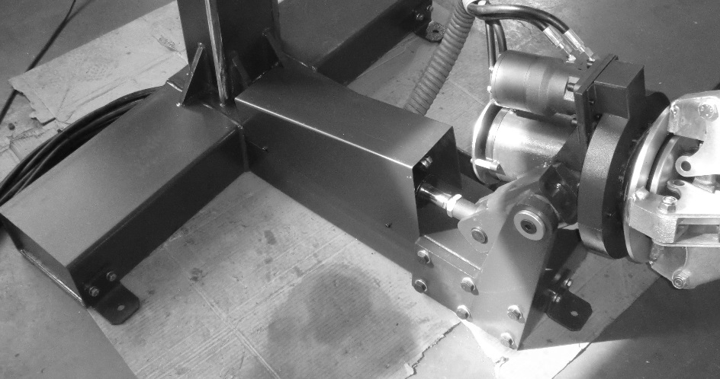 | 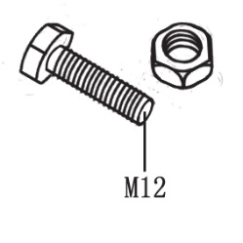
Figure 5 | Figure 6

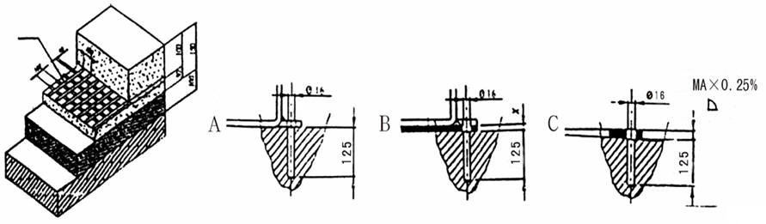
Figure 7

Choose the place there the machine is to be installed, following the enforced work place safety regulations. Check with local building inspectors and/or permits office for any special instructions or approvals required for your installation.
The floor should be solid so that the machine will be stable. Floor should be in generally good condition with no large cracks, spalling or deterioration. Floor should be level within 10 mm over the installation area. No anchors should be installed within 200 mm of any crack, edge, or expansion joint. If these conditions cannot be met, a pad may be poured to accommodate the machine.
CAUTION | Failure by purchaser to provide the recommended mounting surface could result in unsatisfactory machine performance, property damage, or personal injury.

7.2 - NEEDED TOOLS

Beyond the common workshop equipment, the following tools will be necessary:
- Tape measure, 5m
- Chalk line
- 1m level
- Metric open end wrenches 10mm, 13mm, 14mm, 15mm, 17mm, 18mm, 19mm and 24mm
- Metric Allen Wrenches 4mm, 5mm, 6mm, and 8mm.
- Needle Nose pliers
- Snap Ring pliers
- Hammer drill withØ18 - L=100 mm (minimum) widia tap;
- 1 kg hammer
- Torque wrench, 80 N·m minimum with 19 mm Hex socket;
- Anti-Seize lubricant
CAUTION | Listed tools are referred to the specifications of Hilti© anchors type HSL M12/50.

7.3 - WORKPLACE REQUIREMENT

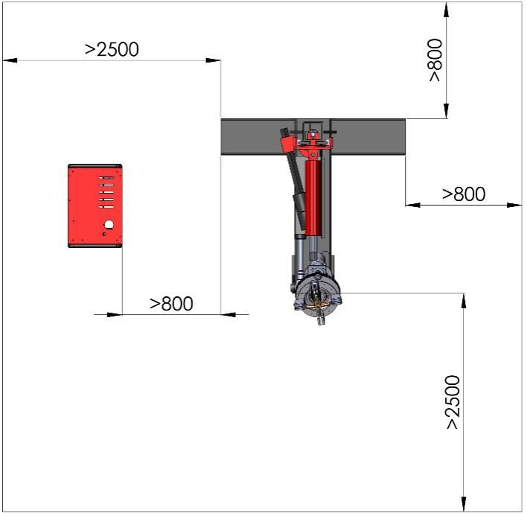
Figure 8

DANGER | Verify that all around the machine there is sufficient space in order to guarantee its correct use, according to the dimensions of the tire to be repaired and in the respect of the local safety norms.  Failure by purchaser to provide adequate clearance could result in unsatisfactory machine performance, property damage, or personal injury.
DANGER | Avoid working in conditions of insufficient light.

Minimum distance from walls and other objects are shown in the Figure 8. Make sure that the installation place is as least 3 meters high.

7.4 - ELECTRIC CONECTION

Before making any electric connection, check to be certain that the mains voltage corresponds to that stamped on the nameplate.
The user will have to supply the connection to the electric line. To doing that he shall use a cable with wires having a minimal section of 2 mm² for each of the phases and of 2.5 mm² for the ground. The cable shall also have a plug compliant to the locally enforced safety laws.
DANGER | If the machine is not provided with a plug, the user should provide a 30A plug for the machine's operating voltage according to the power specification.
ATTENTION | Voltage deviation in the power supply system should be within the rated voltage range ±10%.  The frequency deviation should be within the rated frequency ±1%. Use the necessary protective devices.

The wiring diagram of the machine is the following:
ADD ELECRTIC CIRCUIT
Figure 9

It is absolutely essential that:
- the system is equipped with a good grounding circuit;
- The machine is connected to a power supply line circuit breaker. The power supply cable should be at least 3x1.5mm2+1.5 mm2. And the power supply cable should be marked L1, L2, L3 and PE;
- The current intake is adequately protected against overcurrent with fuses or automatic magneto-thermic switch with rated values 25A.
WARNING | Do not connect the machine to the electric line before having verified that the line itself is completely compliant to the enforced norm. | 
WARNING | Do not connect the machine to the electric line before having verified that there is a properly working grounding circuit and there is a properly working protection circuit.
DANGER | Work on the electric system, even if minor, must be done exclusively by professionally qualified personnel.
WARNING | Make sure the control box can move freely once it has been connected to the electric main line and that it can be displaced around the tire-changer structure without risking of being damaged.
WARNING | After the wiring has been completed, test operation of power unit by running the empty machine for a few test cycles.

Manufacturer shall not be liable for any injury to persons or damage to things caused by failure to comply with these regulations and can cancel warranty coverage.
Connect the machine to the mains, switch "ON" and check that the gearbox motor rotation corresponds to the indicating arrow (Figure 10). If not, switch two wires of the phase conductors.
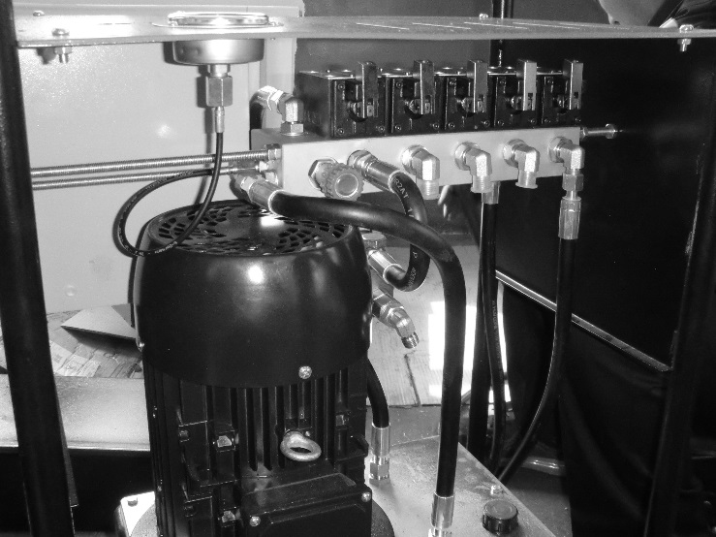
Figure 10

8 - PREPARATION

8.1 - SAFETY PICTOGRAMS

For your safety, and the safety of others, read and understand all of the safety notices and decals included here.
DANGER | The user of the machine must be a person able to fully understand and recognise all the pictograms installed on it. The safety stickers shall not be taken away, damaged or destroyed.  The owner of the machine and/or the person in charge of it shall immediately replace any damaged or partially unreadable pictogram.
Safety decals similar to those shown here are found on a properly installed machine. Be sure that all safety decals have been correctly installed. Verify that all authorized operators know the location of these decals and fully understand their meaning. Replace worn, faded, or damaged decals promptly.
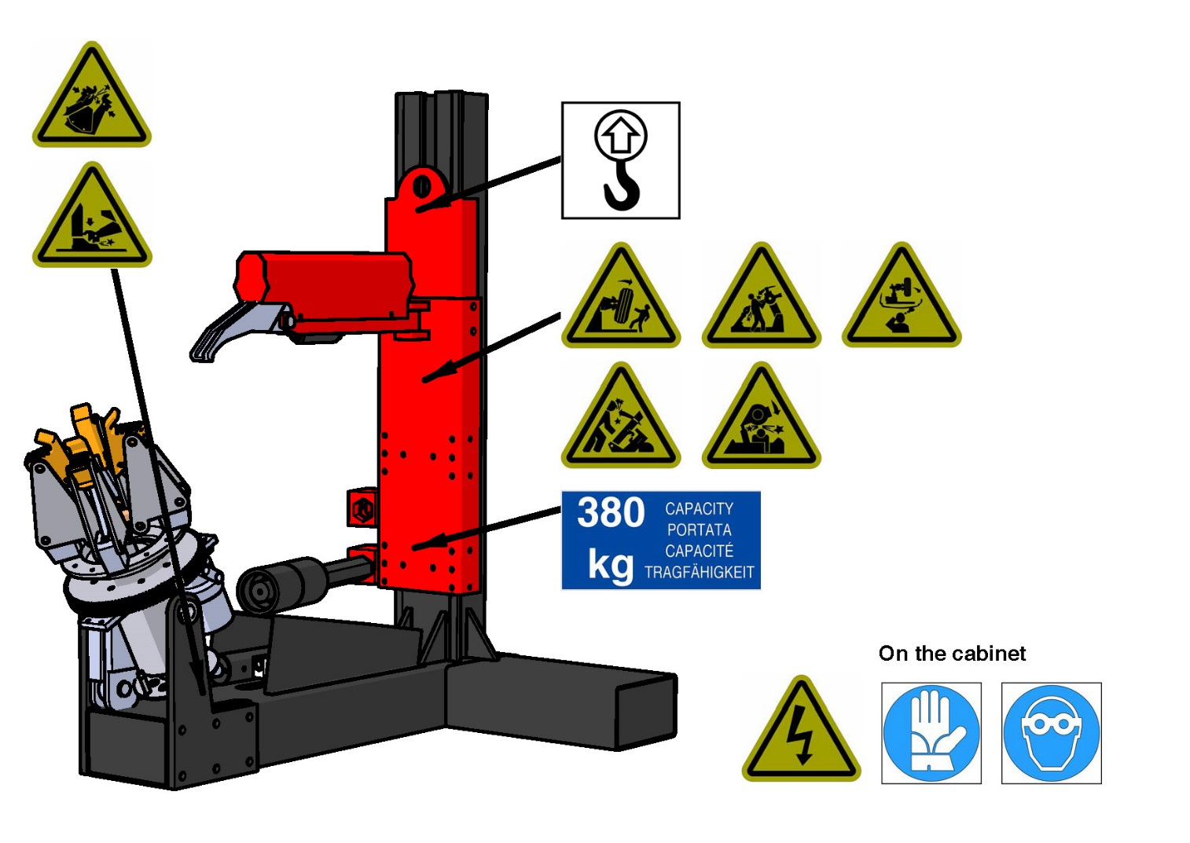
Figure 11

DANGER | Do not attempt to operate the machine until it has been correctly installed and adjusted as described in this manual.
DANGER | Do not attempt to operate the machine until it has been correctly installed and adjusted as described in this manual
DANGER
CAUTION | Do not overload for any reason the machine. The maximum allowable lifting weight is equal to 380 kg; this is understood to be the maximum total weight that can be loaded on the machine, thus it does not refer, e.g., just to the simple empty mass of the tire. |  |  | 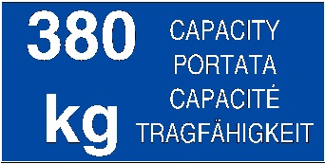
 | Danger: presence of high voltage.  Before performing maintenance work, make sure that the electrical power is disconnected and set the machine to its rest position with the spindle arm lowered and the spindle completely closed.
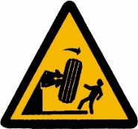 | If the beads come off the rim, the wheel will fall.  Always load, unload and handle the machine paying the utmost attention to possible hazards, in particular make sure that there are no persons or things in the range of the lifting device.
 | Do not leave the working place unattended if the wheel is still mounted on the turntable.
 | Pay attention to the crushing hazard between turntable and tool.
 | Pay attention to the crushing hazard between turntable arm and tire changer body.  The accidental fall down of the tool head for out of control can cause the injury.
 | Feet-crushing hazard during turntable turning or operating.
 | Hand-crushing hazard between turntable jaws.  Always load, unload and handle the machine paying the utmost attention to possible hazards.  Execute any operation on the machine wearing proper protective devices (gloves…).
 | Pay attention to the hitting hazard between turntable arm and tire changer body
Before using the tire changer, make sure that required protective apparels are used (protective gloves, goggles…).
Execute any maintenance, installation and assembly operation on the machine wearing proper protective devices (gloves, shoes…).
 | Before displacing the machine check its centre of gravity and weight to make sure they are compatible with the lifting equipment you are about to use. To displace the packed machine insert a sling/chain in the lifting hooks.  Always load, unload and handle the machine package paying the utmost attention to possible hazards, in particular make sure that there are no persons or things in the range of the lifting device.
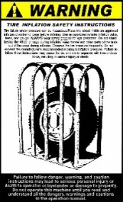 | The failure of the tire under pressure can be very hazardous. Only inflate the tire after having placed the wheel inside an approved inflation chamber.  Do not stand beside the wheel and the cage during the inflation.  Do not exceed the manufacturer recommended maximum inflating pressure.
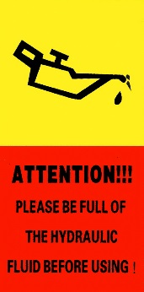 | Make sure that the level of oil in the tank is between the minimum and maximum required.  Check the oil level frequently and top up if needed.  Eventually particular rigid ambient temperatures - below 10°C - could result in slower movements of the machine.  This is not to be considered a defect of the machine; the extent of the effects of a low ambient temperature could be reduced by using a lower viscosity oil. Contact the manufacturer's assistance to get information on the most suitable type of oil to be used. |  | 

8.2 - IDENTIFICATION AND CE MARKING LABEL

On the metallic plate applied to the machine the following information are indelibly indicated:
- Full Name of the Manufacturer.  - Country of Manufacture.  - Model of the machine.  - Date of Manufacturing. |  | - Full address of the Manufacturer.  - Type of the machine.  - Serial number of the machine.  - CE Logo.


The data indicated on the nameplate shall be always called back for any need of assistance and request of spare parts.

8.3 - MACHINE LAYOUT

 |  |  |  | 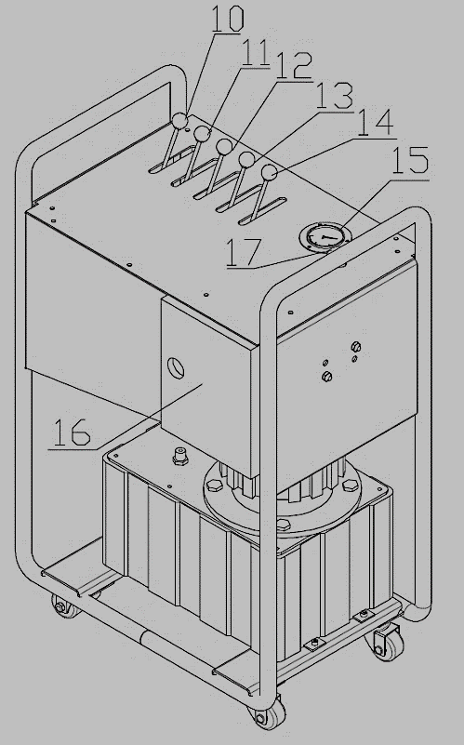
Figure 12
1 | Column support plate | 10 | Hook control lever
2 | Bottom carriage welded | 11 | Column height control lever
3 | Support roller beam | 12 | Chuck angle control lever
4 | Base | 13 | Chuck rotation control lever
5 | Hydraulic cylinder | 14 | Chuck arms control lever
6 | Chuck arms | 15 | Oill pressure indicator
7 | Mobile hook | 16 | Electric control panel
8 | Top carriage welded | 17 | Emergency button
9 | Chuck carrier arm

8.4 – CONTROLS AND WORKING POSITION

On the control unit, the following controls are located:
- Hook control lever (10, Figure 12): when pushed upwards turns the hook down for disassembling the tire from the rim, when pulled down rotates the hook in the rest position;
- Column height control lever (11, Figure 12) when pushed upwards the column and the support roller beam are raised, and when pulled downwards they are lowered.
- Chuck tilting lever (12, Figure 12) when pushed upwards, the chuck is tilted down with its axle parallel to the ground in the “wheel loading” position. When pulled downwards, the chuck is tilted up in the “working position”, with the rim axle perpendicular to the ground.
- Chuck rotation control lever (13, Figure 12) when pushed upwards, the self-centring chuck is rotated counter clockwise. When pulled downwards, the self-centring chuck is rotated clockwise.
- Chuck opening/closing control lever (14, Figure 12) when pushed upwards, opens the arms of the self-centring chuck (locking). When pulled down, closes the arm of the self-centring chuck (un-locking).
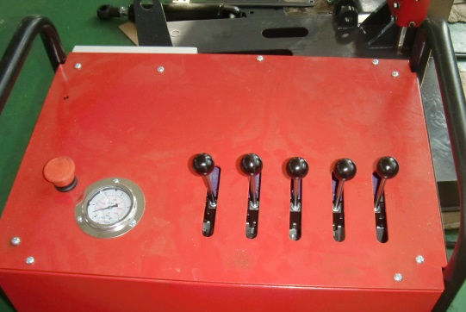
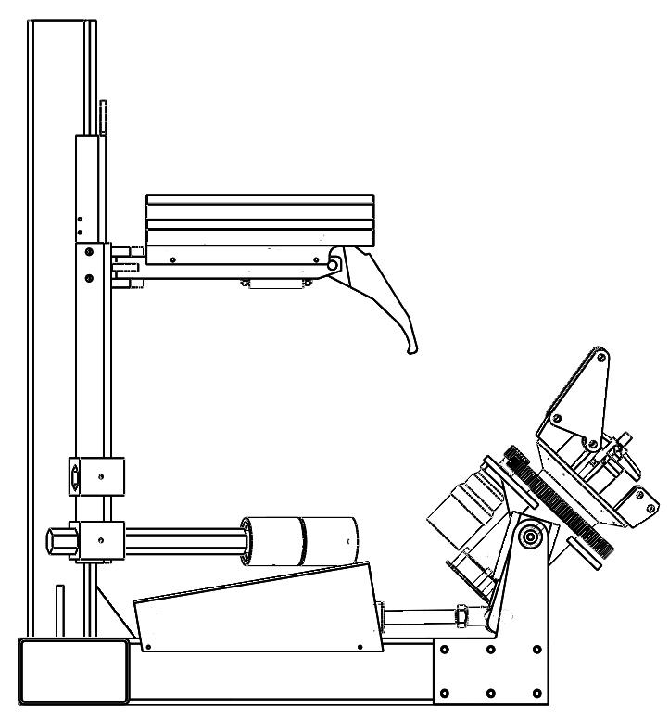
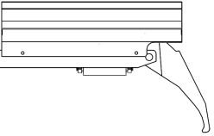
Figure 13

The control unit (Figure 13) can be displaced in any position around the machine, enabling the operator to work at any position around the machine with the best possible visual control on the tire.  Figure 14 illustrates the recommended working position of the control unit B compared to the position of the tire-changer A.  Such position is the one that, while using using the machine, ensures the greatest working precision, speed and safety. | 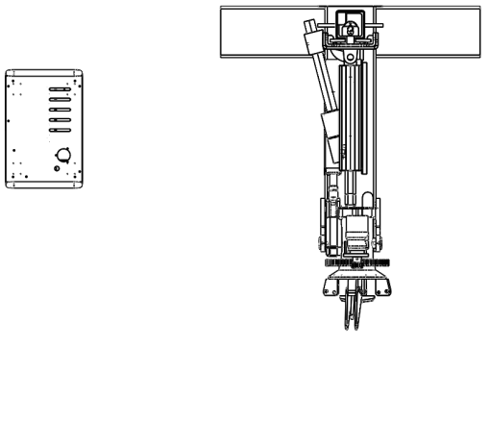
Figure 14
A
B

8.5 - PREPARATION

Before using the tire changer, a number of checks should be made to ensure it works correctly.
CAUTION | The operations described in this chapter, should be carried out only after having positioned the tool carrier arm in its raised rest position
CAUTION | Do not lean part of your body close to the toot carrier arm when you release it to tip it as needed. | 
CAUTION | The tool-holding arm hooding creates a potential crushing hazard. | 
- Check that all levers are in neutral position (no upward or downward).
- If the chuck is not horizontal, push the chuck tilting lever (12, Figure 12) upward until the chuck is in the “wheel loading” position, until the spindle carrier arm horizontal to the ground.
- If the chuck arms are in “locking position”, pull the chunk arms control lever (14, Figure 12) downward until the arms of the chunk are closed in “unlocking position”.
- Make sure that hydraulic circuit is working correctly
CAUTION |  | Pay attention to the potential crushing hazard generated by the spindle carrier arm while being lowered.  Verify that all around the machine there is sufficient space in order to guarantee its correct use, according to the dimensions of the tire to be repaired and in the respect of the local safety norms. |  |  | 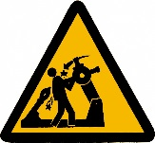
 | CAUTION |  | Pay attention to the potential crushing hazard generated by the spindle arm while being raised/lowered.  Verify that all around the machine there is sufficient space in order to guarantee its correct use, according to the dimensions of the tire to be repaired and in the respect of the local safety norms. | 
 | WARNING |  | If the maximum oil pressure value is not measured within the indicated allowable range, see §5.1 - TECHNICAL DATA, do not use the tire changer and refer to the instructions given in §13 - TROUBLE SHOOTING.  Only trained persons are allowed to adjust the oil pressure setup. If the oil pressure is not within the expected working range, do not tamper with the maximum pressure valve, stop using the tire changer and contact the technical assistance.

8.6 - FINAL ADJUSTMENTS, HYDRAULICS

WARNING | There could be the presence of air in the hydraulic circuit, especially after the first installation or following some maintenance jobs.
WARNING | Oil topping up must be done with the jaw completely raised (rest position), post completely lowered, chuck closed and wheel support lowered.

  - Slowly and carefully loosen the bleed plug on top side of the cylinder just enough to allow the entrapped air to escape.
  - Operate the machine and move and repeat step 1 until no air comes out of cylinder
  - Pressure test hydraulic system. Energize power unit, extend hydraulic cylinders to full stroke and continue to run motor for additional 10 seconds. (NOTE: pressure relief will make a high pitch squeal sound for these 10 seconds.) Check hydraulic system for leaks.
  - Energize power unit again for 10 seconds. With a clean rag, wipe down both cylinder rods.

NOTE: cylinders could be shipped with a small amount of clear anti-corrosive lubricant that will be forced out through the wiper when the cylinders reaches full stroke. If lubricant is not wiped clean from the cylinder rod, the cylinder will appear to be leaking.

8.6.1 - ADDITIONAL INFORMATION ON THE HYDRAULIC CIRCUIT:

WARNING
The most significant components of the hydraulic circuit are:
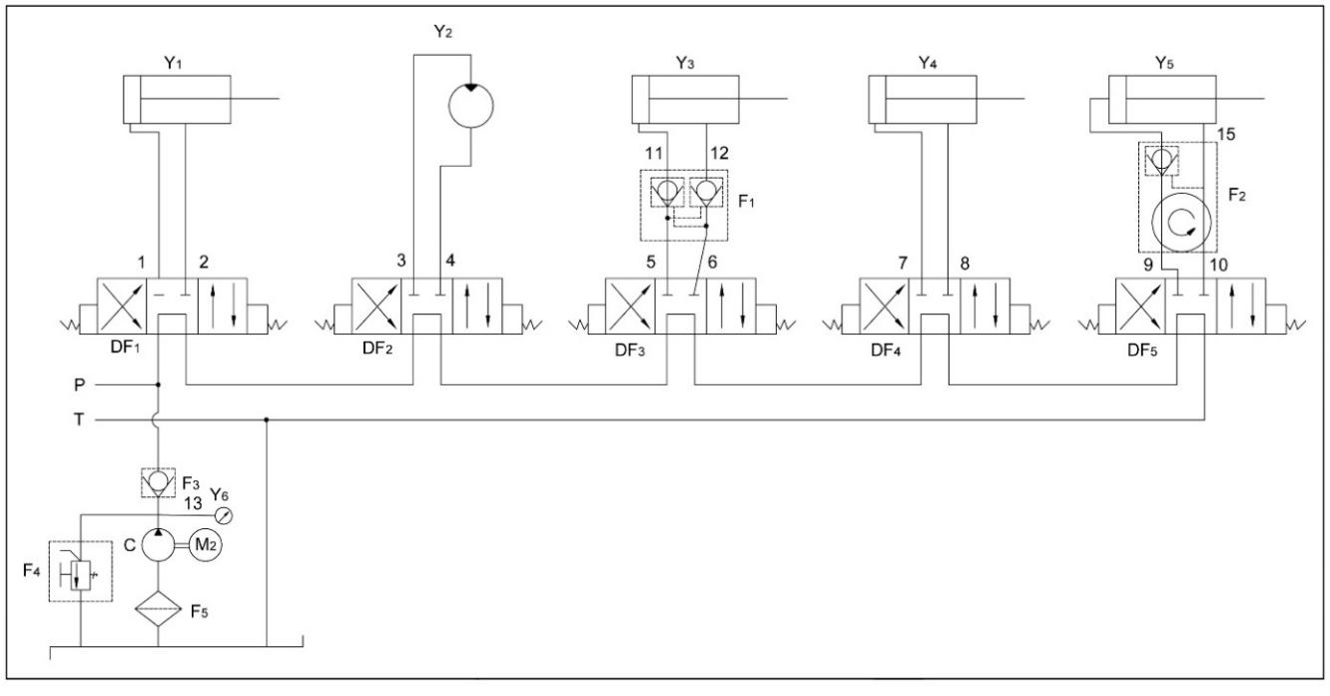
Figure 15

1-2 | Hook rotation cylinder, inlet/return ports |  | F5 | Oil filter
3-4 | Hydraulic motor, CW/CCW rotation ports |  | P | Power pack feed port
5-6 | Spindle tilting cylinder, raising/lowering ports |  | T | Power pack return port
7-8 | Post raising/lowering cylinder ports |  | Y1 | Hook rotation cylinder
9-10 | Spindle chuck opening/closing cylinder ports |  | Y2 | Hydraulic motor
11-12 | Spindle tilting cylinder, feed/return copper lines |  | Y3 | Spindle tilting cylinder
13 | Pressure gauge line |  | Y4 | Post raising/lowering cylinder
14-15 | Spindle clamping cylinder lines |  | Y5 | Spindle chuck opening/closing cylinder
F1 | Spindle tilting cylinder hydraulic lock |  | Y6 | Pressure gauge
F2 | Rotary valve body |  | C | Gear pump
F3 | Check valve |  | M2 | Electric motor
F4 | Relief valve

8.7 - OWNER OPERATOR CHECK LIST

Complete the Installation Checklist/Warranty Validation questionnaire with the owner (see ANNEX I - INSTALLATION CHECK LIST). Review the terms of the warranty registration card, and return the card and a copy of the questionnaires to:

9 - OPERATION

This manual is addressed to the user of Vertical truck tire changer and to the person who has the responsibility of its correct and safe use. This chapter contains warning instructions to operate Vertical truck tire changer properly and prevent injury to operators or objects.
This manual has been written to be used by shop technicians in charge of Vertical truck tire changer (operator) and routine maintenance technician (maintenance operator).
Read carefully the warnings contained in this manual, which is also supplying the indications for a correct and hazard free use of the machine. Familiarize with the controls and the operations required for the use of Vertical truck tire changer in emergency conditions.
Always keep this manual by the machine, in order to consult it in the event of any future possible need. The manual shall follow the machine in case it is sold.

DANGER | The Manufacturer is not responsible for possible damage to people or objects if said operations are carried out by unauthorized personnel or if the machine is improperly used.
DANGER | It is not advisable to operate on particularly old, visually damaged or modified tires, because their reduced strength could generate additional hazards not that cannot be forecastable by the manufacturer. Additional safety precautions are required.
DANGER | Any use of the machine made by operators who are not familiar with the instructions and procedures contained herein is strictly forbidden.
DANGER | The machine was designed to be operated by a single operator only. Third persons are not allowed around the machinery while in use.  In order to prevent risks to third parties and/or damages to things, before any operation takes place and before starting any working cycle, the user shall make sure that there are not things or persons close to the machine.
DANGER | To prevent personal injury from flying objects, check all bolts, nuts and any other part for deformation or elongation prior to each use. Deformed or elongated materials must be promptly replaced. If they look deformed, they are deformed. Replace them!  Immediately point out any problem or breakdown, including eventual defects detected on the control unit and/or on the hydraulic and electric connections, to the owner of the machine or to the person in charge of its safe use.
DANGER | Unauthorized changes and/or modifications to the machine relieve the Manufacturer of any liability for possible damages to objects or people. Do not remove or make inoperative the safety devices, this would cause a violation of safety at work laws and regulations.
DANGER | Before using the tire changer, make sure that required protective apparels are used (protective gloves, goggles…).  Execute any maintenance, installation and assembly operation on the machine wearing proper protective devices (gloves, shoes…).
DANGER | Hand-crushing hazard between turntable jaws.  Always load, unload and handle the machine paying the outmost attention to possible hazards.  Execute any operation on the machine wearing proper protective devices (gloves…). |  | 
DANGER | Feet-crushing hazard during turntable turning or operating.  Always load, unload and handle the machine and its accessories – primarily the roller arms - paying the outmost attention to possible hazards.  Execute any operation on the machine wearing proper protective devices (shoes…). |  | 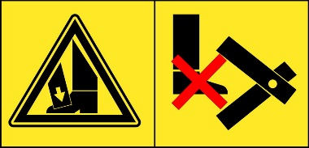
DANGER | In case of an emergency, immediately stop the device by pushing the emergency stop button located on the control box (17, Figure 12). Every time that an emergency stop command is given, the power to the motor is disconnected. In such event, the machine stops and there is no risk of loss of stability due to the presence of hydraulic safety locking devices.  The restoration of power after an interruption cannot lead to an unexpected movement of the load.
ATTENTION | Some type of tires require a special operating procedure, different from the normal tire disassembly process.  In some special rim, see Figure 17), the middle of the rim groove is particularly shallow. Such rims may not comply with the local traffic safety regulations. | 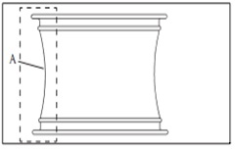
 |  | Figure 16
ATTENTION | When handling tires, pay special attention to the possibility that the rim or tire may be damaged. | 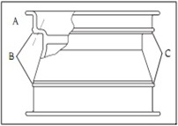
 |  | Figure 17
DANGER | In order to protect the rim, it is required to replace the plastic plug-in for every 2 months.  If the plug is damaged, please replace it immediately

9.1 – IDENTIFYING DIRECTION OF THE RIM

Before mounting the wheel on the machine, you need first to analyse the rim to decide which side of the rim must face up.  In each rim, sections A, B and C – as shown in Figure 18 - can be identified.  When holding the rim on the clamp, minimum dimension C must be placed on top. | 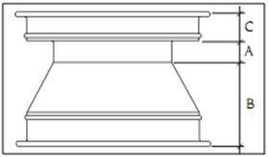
 | Figure 18

DANGER | If the tire is twisted, it is forbidden to install an aluminium alloy rim without having installed first an expansion ring at the rim fixing hole.

9.2 – INSTALLING THE WHEEL ON THE MACHINE

WARNING | Handling of heavy loads:  - up to 35kg, handling is reasonable for one person, no special handling aid required (refer also to EN 1005);  - between 35 and 70kg, handling is reasonable for two persons (check also for space requirements and instructions) or handling/lifting aids provided;  - above 70kg , handling or lifting system required.

Take the mobile control unit to work position B.
- Move the tool-holder arm into the horizontal position.
- Pull the chuck arm control lever downward for positioning the arms in “unlocking” position.
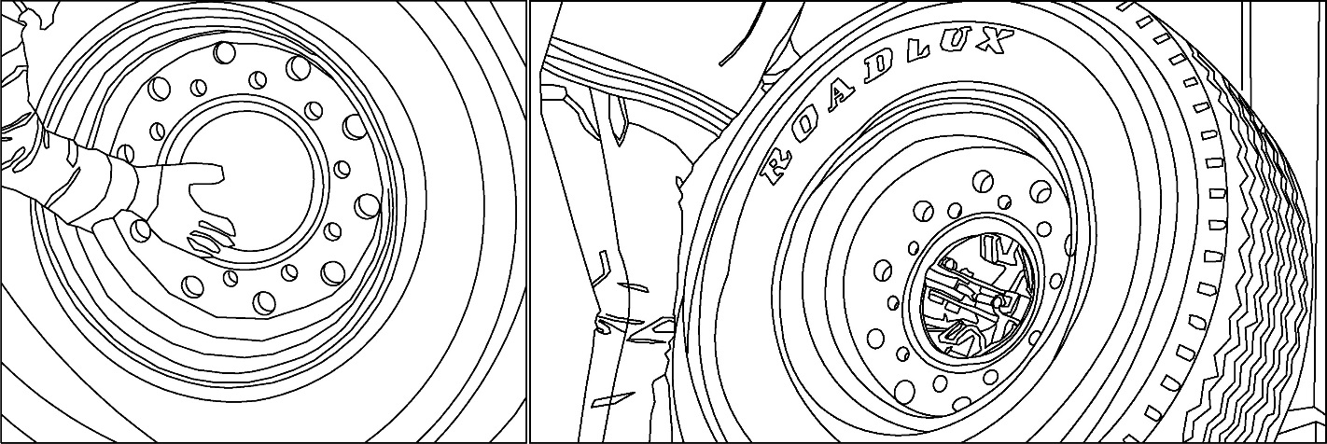
Figure 19

- The operator can approach the rim to the turntable in the work position “A” (Figure 14) then he push slowly the lever for starting open spindle’s arms.
- During this phase, the operator alternates the rim adjustment (work position “A”, Figure 14), with the leverage action at the mobile control centre (work position “B”, Figure 14), until the centring is over.
DANGER | Hand-crushing hazard between turntable jaws.  Always load, unload and handle the machine paying the outmost attention to possible hazards.  Execute any operation on the machine wearing proper protective devices (gloves…).
- The wheel is locked when turntable’s clamps jams the rim as can be seen in Figure 20.
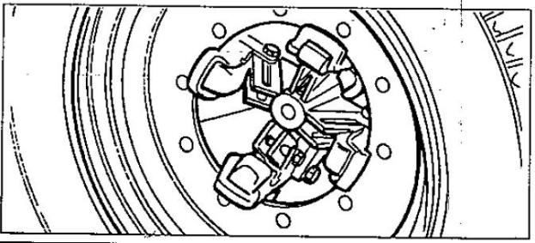
Figure 20

CAUTION | Do not leave the working place unattended if the wheel is still mounted on the turntable. | 
DANGER | Before lifting the chuck, make sure that the rim is firmly held on the jaw.

9.3 – OPERATION

Before any starting any operation, remove the balancing ballasts and deflate the tire.
Lower the post and press the tire roll against the tire crest. Rotate the tire until the rim of the tire is peeled off the rim. To facilitate this operation, lubricate the bead and the edge of the rim with tire grease whilst the wheel is in rotation.
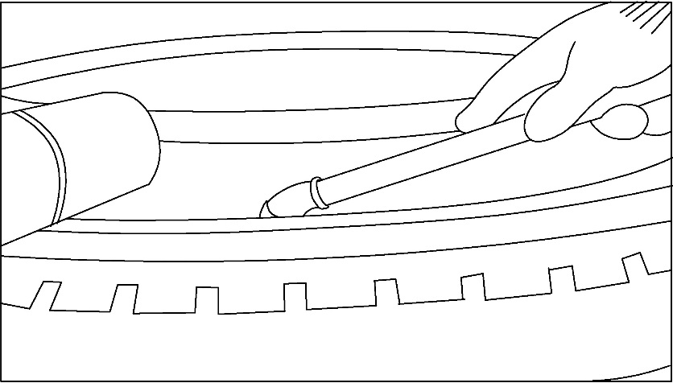
Figure 21

ATTENTION | The following instructions are considering that when removing and installing tires, tires are rotated counter-clockwise. If something obstructs the tire while mounting/demounting it, immediately stop working and rotate the rim clockwise to remove the obstruction.
ATTENTION | Failure to properly grease the rim may lead to serious damage of the tire. Only use professional grade tire-grease to lubricate the rim.  To avoid risks of being trapped in the rollers while greasing the rim, only use a long handled brush and never turn the wheel by operating the turntable.
DANGER | Keep the hands off the tires while operating the tire changer. Remove bracelets and avoid loose clothes or any other accessories that may endanger the operator. In order to prevent the occurrence of an accident, when operating the tire rotation, keep the hands and any other part of the body as far as possible from the removable hook and the tire rolling parts

9.4 – TIRE REMOVAL

Before any starting any operation, remove the balancing ballasts and deflate the tire.
- Tilt the mounting arm in the rest position and make sure that the hook faces the tire;
- By tilting the hook with the control lever (10, Figure 12), insert it between the rim and the edge of the tire;

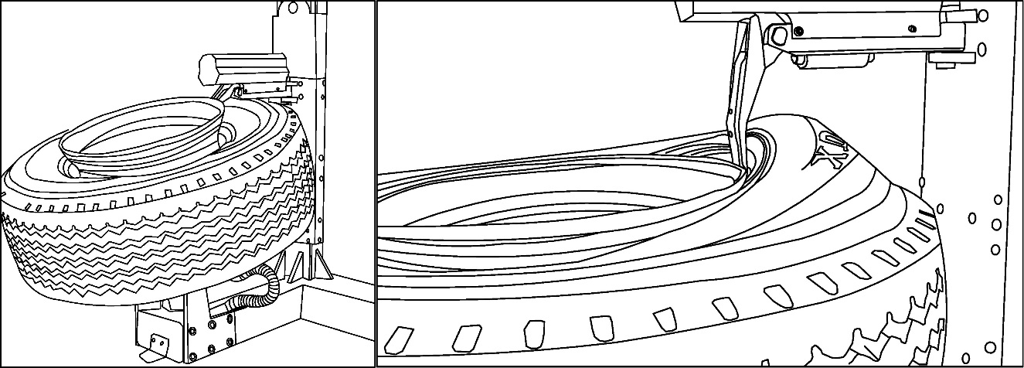
Figure 22

- By lifting the post (11, Figure 12), raise the edge of the tire upwards to prevent the tire edge from disengaging from the mounting hook.
- Remove the side of the tire by turning the wheel counter-clockwise, operating the wheel rotation lever (13, Figure 12).
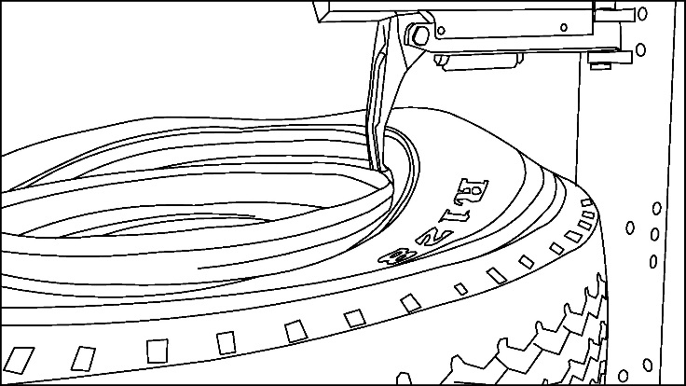 | 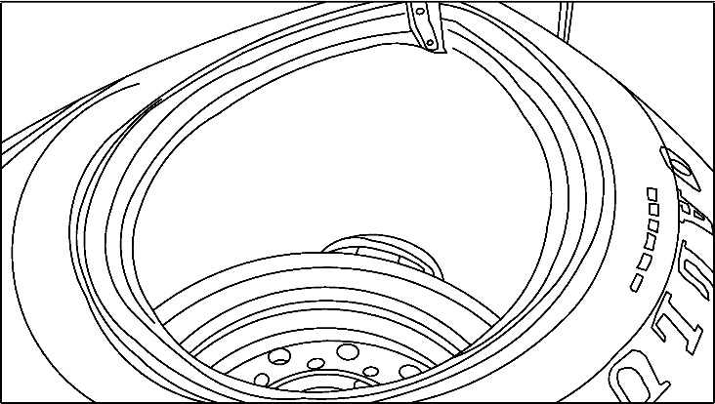
Figure 23 | Figure 24

- Move the mounting roller to the lower side of the tire, hold the second layer of the tire side with the side of the tire roller, hold the lower edge of the tire above the rim, and then turn the tire to completely remove the tire.
- Slightly tilt the chuck horizontal, enough to clear the assembly arm and allow the post to be raised;
ATTENTION | Make sure that while raising the post, the assembly arm does not get in contact with the wheel/rim being disassembled. Operate the machinery slowly to have a better control of the operation and avoid damaging the machine or the tire being disassembled

- Raise the post assembly;
- Completely tilt the chuck and remove the entire tire.

9.5 – TIRE INSTALLATION

ATTENTION | Before mounting and inflating a tire, it is necessary to understand its technical characteristics, its working parameters, the eventual functional features and security level. Relevant information are normally marked on the side of the tire.
ATTENTION | Make sure that the tire is repaired and the it is air-tight before installing it on the rim.

Preliminary check before install the tyre on the rim:
- Make sure that the tire is in good condition without signs of damage ;
- Make sure that the relevant parameters of the tire and of the rim match;
- Make sure that the rim is not deformed, damaged, rusted nor that shows any dent on the edge;
- Make sure that the centre hole of the rim is not damaged.
- Prepare the tire by lubricating its lips with professional tire-grease. Apply the grease both to the tire and to the rim;
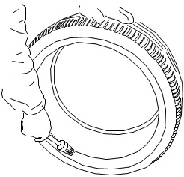 | 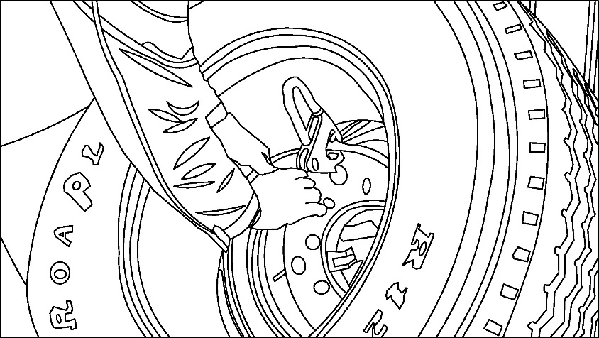
Figure 25 | Figure 26

- Locate the rim on the clamp and firmly hold it, as explained earlier;
- Position the tire pliers at the highest point outside the rim of the rim;
- Place the tire on the rim and tilt it by 45 °. Make sure the pliers can hold the tires completely and the tires cannot fall off;
- Raise the post the highest point and tilt the rim and tire upwards;
- Adjust the pressure roller and tire, check in particular the distance between the rim and the roller arm and make sure that they do not touch;
- Rotate the tire keeping it pressed with the roller.
ATTENTION | Observe the state of the tire during the rotation, if the rim is eating the tire, press the roller to re-press the tire.

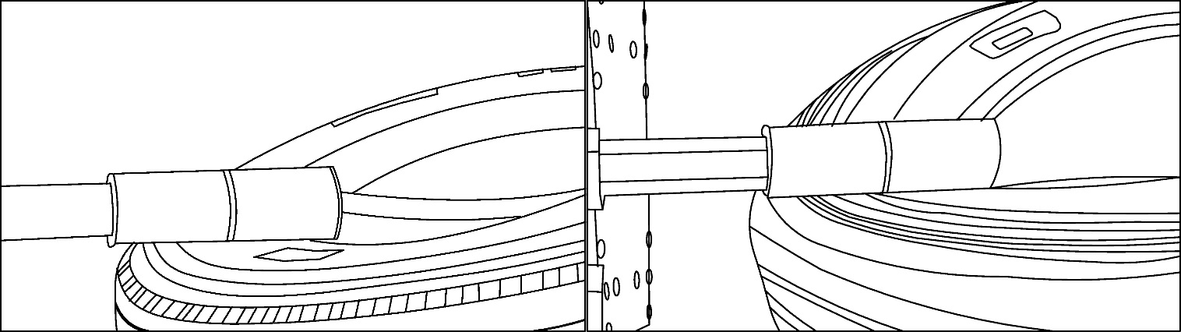
Figure 27

- Continue to press the tire with the tire roll and press the lower bead fully into the rim;
- Hold the pliers on the outside of the rim and rotate the motor to fit its outer tires into the rim;
- Remove the pliers from the rim and use the press roller to disengage the tire.
- Tilt the tire down and open the locking jaws to free the rim.
DANGER | Feet-crushing hazard during turntable turning or operating.  Always load, unload and handle the machine paying the outmost attention to possible hazards.  Execute any operation on the machine wearing proper protective devices (shoes…).

9.6 – OPERATING ON SPECIAL TIRES

In some special rims, the middle section of the rim is particularly shallow, see Figure 16.
ATTENTION | Rims with a particularly shallow central section, require a different demounting procedure because the hook may not completely hook the tire in place.  The operator should then check the tire and find the best disassembly hook position, which will hold the tire in place.

9.7 – INFLATING THE TIRE

- Remove the air cap and place the air tip on the top of the gas nozzle. Inflate the tires.
ATTENTION | To avoid tire pressure exceeds the maximum pressure, frequent stop inflating to check the tire internal pressure, until the required tire pressure to is met.

DANGER |  |  | The failure of the tire under pressure can be very hazardous. Tire explosion may cause serious injury to the operator and even cause death.  Only inflate the tire after having placed the wheel inside an approved inflation chamber.  Do not stand beside the wheel and the cage during the inflation.  Do not exceed the manufacturer recommended maximum inflating pressure.
DANGER | Do not exceed the maximum pressure specified by the tire manufacturer.  The operator must stay as far as possible from the tires, when inflating it.  Before inflating the tire:  - Check carefully whether the rim is the same size as the tire;  - Check the wear status of the tire;  - Install a new gas nozzle on the rim;  - Make sure the tire is well lubricated.  While inflating the tire:  - Check tire pressure frequently;  - Never inflate at a pressure higher of 3.5bar and , in any case, do not exceed the manufacturer's recommended pressure;  - Keep body and hands as far as possible away from the tires;  - Make sure that the rim is firmly held on the chuck;  - Make sure that the removable head and the tire roller have been removed and are located as far as possible from the tire being inflated;
DANGER |  | Even if the machine is not particularly noisy, during inflating operation the noise may reach up to 85dB (A). The operator must use the associated protective equipment.

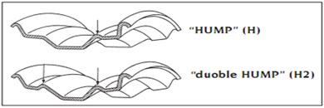
Figure 28

ATTENTION | Tubeless tires require a large amount of air flow to be inflated. If the air flow is insufficient, the bead can not slip over the lower part of the lip through the convex part (HUMP). To increase the air flow, you can remove the gas nozzle inside the gas core. HUMP is an essential component for a safe driving.

- Check the bead and steel ring fit. If there is a problem, you must deflate the tire, re-extract the tire side, lubricate the tire side and, after installing back in place, re-inflate the tire.
- Adjust the tire pressure, eventually press the deflation button to discharge excess pressure;
ATTENTION | Ensuring proper tire pressure is important for safe use of car tires:  - Excessively low tire pressure will lead to tire overheating, serious wear and tear, shorten the tire life, tire damage, and increase the vehicle consumption;  - Excessively high tire pressure will lead to vulnerability to damage in the event of a collision and will increase the tire tread wear.
ATTENTION | Check tire pressure at ambient temperature, do not detect nor adjust the tire pressure when the tire temperature is too high.  Tire can be considered at ambient temperature if the vehicle has not been driven for at least one hour or if it has only been driven briefly at a low speed not exceeding 2-3 km/h.

- Install the valve cap.
ATTENTION | When the equipment is not being used, turn the main switch on the OFF position and cut off the power to ensure that the equipment is used by unauthorised persons.

10 - ORDINARY MAINTENANCE

ATTENTION | Vertical truck tire changer. If the machine is not maintained on a regular basis, its functionality and reliability is not guaranteed and the operator and the persons near the machine are at risk.
DANGER | If any problem is encountered, contact your local service representative.  DO NOT OPERATE A DAMAGED MACHINE
DANGER | Prior to any kind of maintenance and/or cleaning operation is performed, unload the machine and put it in its rest position, make sure that there is no pressure in the hydraulic hoses and disconnect the power source from the machine.
WARNING | Only trained and authorized persons shall be allowed to maintenance/operate this equipment.  Copy of this manual shall be given to any person authorized to operate the machine; the owner of the machine shall make sure that any person authorized to use the machine has fully read and understood the present manual, therefore knowing how to use the machine in safe conditions.
DANGER
DANGER | The machine was designed considering an expected life of 20000 working cycles. Exceeding this working life could result in fatigue overload of the structure and could affect the safe use of the machine. Fatigue is an inevitable effect of the use of the machine and should be taken in proper account. A good maintenance is extremely important not to make the effect of fatigue on the structure worse than they actually are.
DANGER | After any kind of maintenance and/or cleaning operation are performed, before re-starting the machine, make sure that all the protective devices are correctly mounted and that they have not been damaged.  DO NOT OPERATE A DAMAGED MACHINE.
DANGER | If this machine catches fire, use dust or CO² extinguisher only.

To reduce the effects of the wear consequence of the use of Vertical truck tire changer, it is necessary to execute a correct and regular maintenance. This type of activity, first of all extends the life of the machine, but also it is fundamental for its safe use.
The following maintenance points are suggested as the basis of a routine maintenance program. The actual maintenance program should be tailored to the installation.

10.1 - PERIODICAL CHECKS

For the proper conservation of the system, provide for the regular cleaning of the machine by removing all the dust and/or parts of cloth lost while working. When cleaning, use non-corrosive and non-pollutant detergents that do not react with the paints used on the machine.
WARNING | Keep the workplace clean and tidy.  Clean up the machine after every working session, removing all the impurities that could, with the time, being cause of malfunctions and dangers. If liquids were spilled, dry up the machine as soon as possible.
ATTENTION | To avoid the formation of dust in working environment, do not use compressed air to blow away impurities.

Every day:
- Keep machine components clean;
- Check for loose or broken parts;
- Check hydraulic system for fluid leaks;

Every 3 months:
- Check hydraulic circuit, check oil tank level; refill with oil, if needed;
- Check hydraulic circuit, Check seals for proper conditions and replace them, if necessary;
- Check Foundation bolts, check bolts for proper tightening;
- Check Hydraulic pump, verify that no noise changes take place in the pump of the control desk when running and check fixing bolts for proper tightening;
- Check Safety system, check safety devices for proper operation

Every 6 months:
- Check oil for contamination or ageing. Contaminated oil is the main reason for failure of valves and shorter life of gears pumps;

Every 12 months:
- Verify that all components and mechanisms are not damaged;
- Check Electrical system, verify that control desk motor, limit switches and control panel operate properly must be carried out by skilled electricians;
- Empty the oil tank and replace all the hydraulic oil.

10.2 - SPECIFIC CHECKS

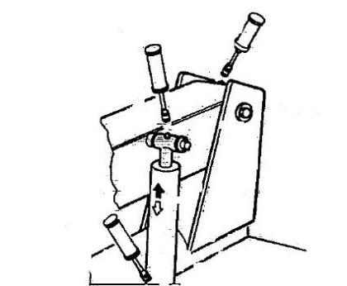 | 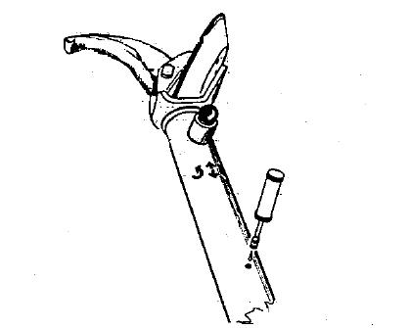
Figure 29 | Figure 30

- Replace all Safety, Warning or Caution Labels if missing or damaged;
- Lubricate and clean periodically the sliding/pivoting parts;
- Grease periodically the spindle bracket cylinder. Add grease through the greasing nipples (See Figure 29) using ordinary lubricating grease.
- In the same way, grease the tool holder arm cylinder (See Figure 30).
- Periodically check the oil level in the tank. Refer to the max/min level indicated in the oil level stick present on the tank cap.
- If machine stops short of full rise or chatters, check fluid level and bleed both cylinders per Installation Instructions. If necessary top up with Esso Nuto H46 or similar hydraulic oil (eg.Agip Oso46, Shell Tellus Oil 46, Mobil DTE25, Castrol Hyspin AWS 46, Chevron RPM EP Hydraulic Oil 46, BP Energol HLP).
DANGER | The complete change of all the hydraulic oil and the cleaning of the tank are strongly advised every 5 years or after every 500 days of use. The exhausted oil will have to be scraped according to the locally enforced laws.
ATTENTION | Avoid direct contact of the oil with the skin, while changing it.  Execute any maintenance, installation and assembly operation on the machine wearing proper protective devices (gloves, shoes…).  Do not wear oily clothes. Immediately change dirty clothes and wash hands with water and soap before resuming working.
ATTENTION | Do not smoke while performing any maintenance, installation and assembly operation on the machine.
WARNING | The oil tank cap should not be opened by un-trained person.  Before starting a working cycle, the operator must make sure to put the cap back in place and tighten it.
WARNING | Eventually particular rigid ambient temperatures - below 10°C - could result in slower movements of the machine. This is not to be considered a defect of the machine; the extent of the effects of a low ambient temperature could be reduced by using a lower viscosity oil. Contact the manufacturer's assistance to get information on the most suitable type of oil to be used. | 

- Check the horizontal arm periodically.
N.B.: There may be some mechanical play at the tool-holder arm, or while moving it, during the assembly and disassembly operations. For longer component working life, it is advisable to adjust the slide shoes as described below.

10.3 – OIL SAFETY DATASHEET

Hydraulic Oil 46:
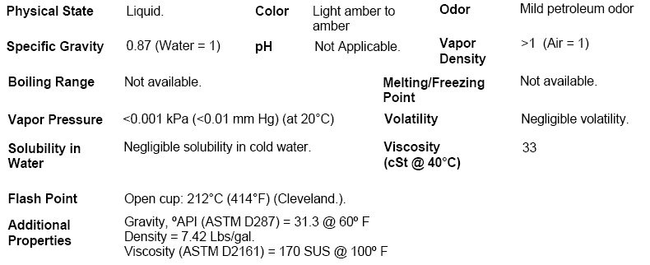

Hydraulic Oil 32:
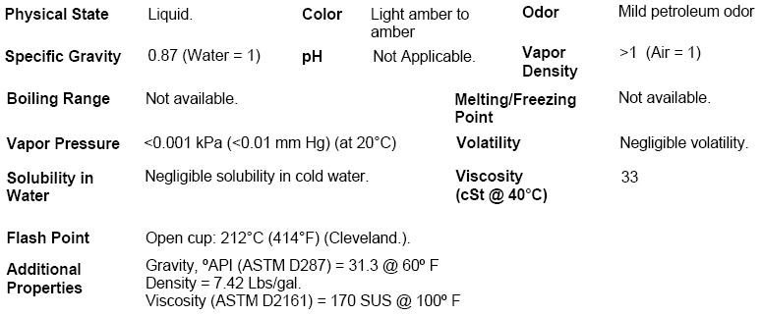

11 - DISMANTLING OF THE MACHINE AND SCRAPPING

The system must be put out of service and disassembled only when its replacement has been decided. Regardless of any considerations on the convenience of the reuse of the machine either in part or as a whole, it must be stressed that the scattering of potentially toxic components is extremely hazardous. The machine was built mainly with metals, plastic materials, electric power cables, oils and lubricants.
If the demolition is carried out by your personnel, the various components must be divided by sorting them by type. These are to be handed over to specialized (and authorized) firms for the disposal of the various materials:
- Aluminium-steel-copper
- Plastic-rubber
ATTENTION | Execute any dismantling operation on the machine wearing proper protective devices (gloves, shoes…).
WARNING | Hand over the used hydraulic oil only to the authorised firms that operate in compliance with the locally enforced law.
WARNING | Hand over all the scrapped material to authorised companies that operate in compliance with the locally enforced law.
WARNING | Do not dismantle/displace the machine, if the air supply and power supply are not cut off.

12 - TECHNICAL ASSISTANCE

13 - TROUBLE SHOOTING

SYMPTOMS | CHECK POINT | ACTION
The spindle disc cannot be rotated | Remove the gear cover, observe the gear meshing, pinion is broken or damaged. | Eventually replace the pinion
The spindle disc cannot be rotated | Check if the hydraulic motor turns freely. | Eventually replace the hydraulic motor
The control stem do not move freely or – once released – do not return in the rest position. | Check manually operated hydraulic valve | Replace, if necessary.
The spindle disc cannot hold the steel ring. | Spindle cylinder is damaged. | Replace the spindle cylinder.
The spindle disc cannot hold the steel ring. | Spindle cylinder is damaged. | Replace the spindle internal seal.
The spindle disc cannot hold the steel ring. | Spindle cylinder is damaged. | Replace the rotary valve.
Oil leakage on the cylinder rod | Check seals for wear | Replace seals, if necessary.
Oil leakage on the cylinder rod | Check the hydraulic cylinder is damaged. | Replace cylinder or piston rod, as necessary.
Oil leakage on the hydraulic circuit | Leakage on a control valve. | Replace the valve, if necessary.
Oil leakage on the hydraulic circuit | Hoses/fittings are leaking. | Use a wrench to tighten the tubing connection. Eventually replace damaged or worn hoses/fittings.
The hydraulic pump is noisy | Check gear pump for damages | Replace gear pump, if necessary.

14 - SPARE PARTS

WARNING | When requesting spare parts, it is highly recommended to always specify not only the name of the person ordering them, the name of the Company and the telephone number, but also the following data:  - DESCRIPTION OF THE MACHINE ON WHICH THE ITEM IS MOUNTED  - MACHINE SERIAL NUMBER  - DESCRIPTION OF THE ITEM  - NUMBER OF PIECES OF THE REQUIRED ITEM
WARNING

14.1 - SPARE PARTS BREAKDOWN

Item # | Part # | Qty. | Description |  | Item # | Part # | Qty. | Description
1 |  |  |  |  | 21
2 |  |  |  |  | 22
3 |  |  |  |  | 23
4 |  |  |  |  | 24
5 |  |  |  |  | 25
6 |  |  |  |  | 26
7 |  |  |  |  | 27
8 |  |  |  |  | 28
9 |  |  |  |  | 29
10 |  |  |  |  | 30
11 |  |  |  |  | 31
12 |  |  |  |  | 32
13 |  |  |  |  | 33
14 |  |  |  |  | 34
15 |  |  |  |  | 35
16 |  |  |  |  | 36
17 |  |  |  |  | 37
18 |  |  |  |  | 38
19 |  |  |  |  | 39
20 |  |  |  |  | 40

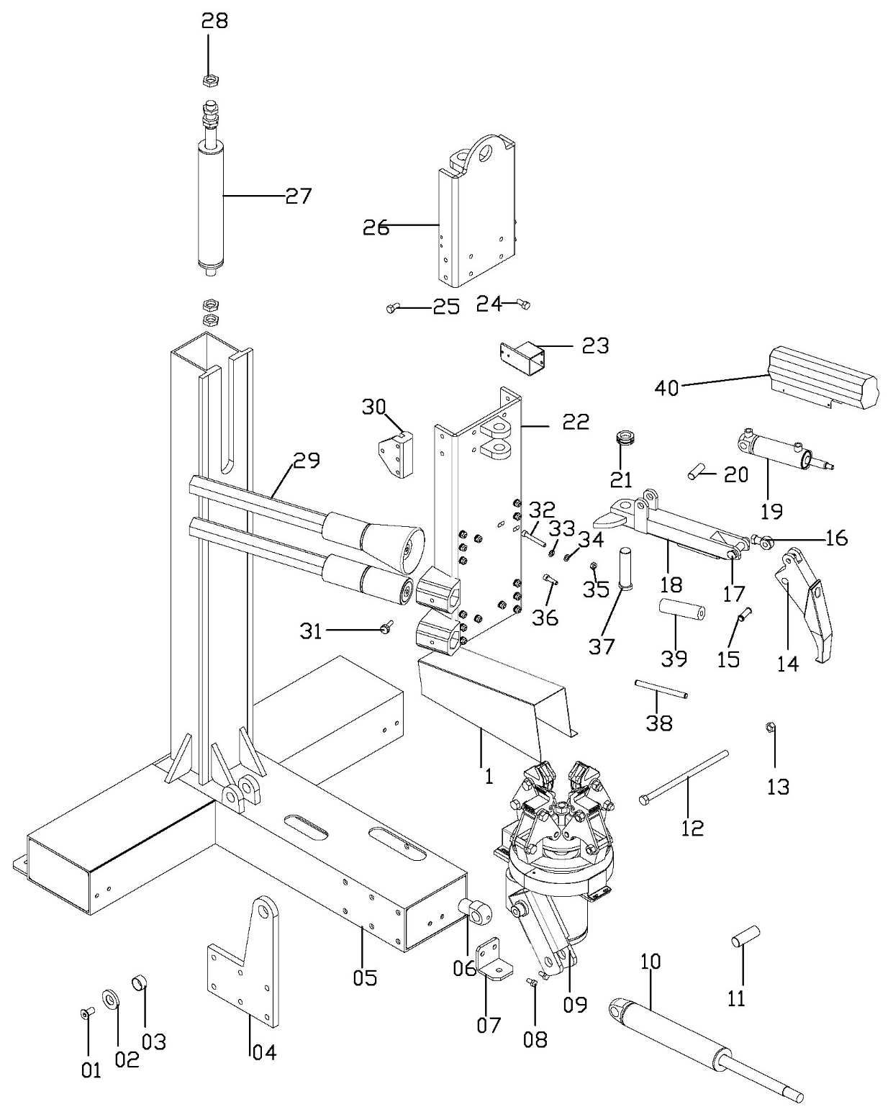
Figure 31

15 - ACCESSORIES

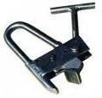 | 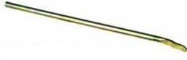
Figure 32 | Figure 33

ANNEX I - INSTALLATION CHECK LIST

Check # | CHECK DESCRIPTION |  |  |  | YES |  | NO | NOTES
1 | Check of the quality of the ground where the machine is to be installed.  Concrete type___________ and thickness____________
2 | Check of the minimum safety distances from walls, other machines…
3 | Check of the electric supply for compliance to applicable safety norms.
4 | Functional check of the machine.  - Complete cycles to eliminate air from the hydraulic circuit.  - Maximum pressure valve setup is correct.
5 | Functional check of the machine, full load.
6 | Check that the machine is securely fixed to the ground.
7 | Check the oil level.
8 | Check for eventual oil leakages.
9 | Use instructions were delivered together with the machine.
NOTES
INSTALLATION SITE ADDRESS: |  |  |  | RESULT OF THE CHECK |  |  |  |  | ACCEPTED | REJECTED
CUSTOMER |  | STAMP |  |  |  | SIGNATURE
 |  | STAMP |  |  |  | SIGNATURE
DATE |  |  | NEXT CHECK

ANNEX II - PERIODICAL CHECKS

Check # | CHECK DESCRIPTION |  |  |  | YES | NO |  | NOTES
1 | Check cleanliness of the machine
2 | Check oil level
3 | Grease Sliding Pad rails
4 | Grease Moving parts (pins and bushes)
5 | Check hoses on hydraulic connections
6 | Check for eventual oil leakages
7 | Check oil for contamination
8 | Check max pressure valve setup.
9 | Functional check of the machine.  - UP/DOWN cycles to eliminate air from the hydraulic circuit.  - Maximum pressure valve setup is correct.
NOTES
Complete replacement of the hydraulic oil |  | YES NO Type of oil used: _________________________________
RESULT OF THE CHECK |  |  |  |  |  |  |  |  | ACCEPTED | REJECTED
CUSTOMER |  |  | STAMP |  |  |  | SIGNATURE
DATE |  |  |  | NEXT CHECK

EC DECLARATION OF CONFORMITY

IS COMPLIANT TO THE PROVISIONS OF THE FOLLOWING DIRECTIVES:

 | 2006/42/EC | 2014/30/UE

IS COMPLIANT TO THE FOLLOWING REFERENCE STANDARDS:

UNI EN ISO 12100 | CEI EN 60204‐1 | UNI EN ISO 13857
 | EN ISO 11202 | EN ISO 13850

The template of this declaration is in compliance with the provisions of the EN ISO/IEC 17050/2005 standard.

Serial Number
_ _ _ _ _ _ _ _ _ _ _ _

